ANJEE Site – NJ’s Clean Energy Program

Intro Video: NJ's Clean Energy Program Intro Video

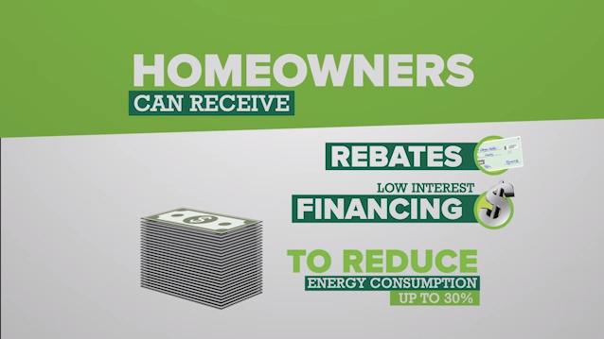
New Jersey's Clean Energy Program is a statewide program that offers financial incentives, programs and services for New Jersey residents, business owners and local governments to help them save energy, money and the environment.

During this difficult time of the COVID-19 virus, we realize that many NJ residents are looking for new ways to save money. NJ’s Clean Energy Program offers rebates on new energy efficient appliances. For more information, see this section of our website: https://www.njcleanenergy.com/rebates

For details on the full spectrum of ways to save energy, money and the environment, please visit our website: njcleanenergy.com

To speak to a Program Representative, please call us at 866-NJSMART (866-657-6278)
or, contact us by email.

